Jai Jalaram Packaging Web Application
- Introduction :
  - purpose
- This document defines the functional and non-functional requirements of the Jai Jalaram Packaging web application.
- The system is designed to provide an online platform for packaging product sales, custom box requests, order management, invoicing, and inventory tracking.

  - Scope
- The system provides the following features:
- User registration with OTP verification
- Secure login with role-based access (Admin & Customer)
- Product browsing and cart-based ordering
- Custom packaging order with PDF design upload
- Admin order approval and status tracking
- Invoice generation and PDF download
- Inventory and revenue management
- Email notifications for system events

1.3 Definitions
Term | Description
Customer | User who places orders
Admin | User who manages system operations
Product Order | Order of standard catalog items
Custom Order | Order with custom dimensions and design

- Description :

  - Product Perspective :
The system is a full-stack web application:
- Frontend: React.js
- Backend: Node.js + Express
- Database: MySQL
2.2 User Classes
Customer
- Register & login
- Browse products
- Place orders
- Track order status
- Chat with admin
- Download invoices

Admin
- Manage products & inventory
- Approve/reject orders
- Generate invoices
- Track revenue
- Manage customers

2.3 Operating Environment

- Frontend: React (Create React App)
- Backend: Node.js / Express
- Database: MySQL
- Email Service: SMTP (Nodemailer)

2.4 Constraints
- JWT authentication required
- Admin identified via predefined email list
- File upload limits:
  - PDF ≤ 5MB
  - Image ≤ 10MB
- Orders blocked if stock unavailable

2.5 Assumptions
- MySQL server is configured
- SMTP credentials available
- Environment variables configured

3. Functional Requirements
FR-1 Authentication
- User registration with OTP
- Login with email/password
- Role-based access (Admin/Customer)
- Password reset via email
FR-2 User Profile
- View profile
- Update details (name, phone, address)
FR-3 Product Catalog
- View all products
- Admin can add/update/delete products
- Low-stock alert for admin
- Admin add material
FR-4 Product Ordering
- Add items to cart
- Place multi-product order
- Automatic price calculation
- Prevent order if stock unavailable
FR-5 Custom Box Ordering
- Enter dimensions & quantity
- Upload design PDF
- Phone validation
- Price calculation based on size
FR-6 Order Management
- Admin views all orders
- Update order status
- Reduce stock after approval
- Notify customer via email
FR-7 Chat System
- Customer ↔ Admin communication
- Store messages with timestamp
FR-8 Invoice System
- Generate invoice after order completion
- Auto invoice number
- Download PDF
- Share invoice with customer
FR-10 Material Management
- Add/update/delete materials
- Track stock & cost
- Calculate inventory value

4. Data Requirements
Main Entities
- User → name, email, phone, role
- Product → name, price, stock
- Order → type, quantity, status
- Invoice → number, order_id, amount
- Payment → amount, method
- Material → quantity, price

Users Table
Stores all registered users (Admin & Customer).
Field | Type | Description
id | INT (PK) | Unique user ID
name | VARCHAR | User name
email | VARCHAR (Unique) | Email address
phone | VARCHAR | Phone number
address | TEXT | User address
password | VARCHAR | Encrypted password
role | ENUM | admin / customer
created_at | TIMESTAMP | Registration time

Products Table
Stores packaging product details.
Field | Type | Description
id | INT (PK) | Product ID
name | VARCHAR | Product name
description | TEXT | Product details
price | DECIMAL | Product price
stock | INT | Available stock
image | LONGTEXT | Product image
created_at | TIMESTAMP | Created date

Orders Table
Stores all customer orders.
Field | Type | Description
id | INT (PK) | Order ID
user_id | INT (FK) | Linked user
order_type | ENUM | product / custom
total_price | DECIMAL | Total amount
status | ENUM | pending / approved / rejected / completed
customer_name | VARCHAR | Customer name
phone | VARCHAR | Phone
dimensions | VARCHAR | Custom size
design_file | LONGTEXT | PDF file
created_at | TIMESTAMP | Order date

Order Items Table
Stores products inside an order.
Field | Type | Description
id | INT (PK) | Item ID
order_id | INT (FK) | Order reference
product_id | INT (FK) | Product reference
quantity | INT | Quantity
price | DECIMAL | Price
Invoices Table
Stores generated invoices.
Field | Type | Description
id | INT (PK) | Invoice ID
order_id | INT (FK) | Linked order
invoice_number | VARCHAR | Unique number
total_amount | DECIMAL | Amount
shared | BOOLEAN | Shared with customer
created_at | TIMESTAMP | Date

Payments Table
Stores payment records.
Field | Type | Description
id | INT (PK) | Payment ID
order_id | INT (FK) | Order reference
amount | DECIMAL | Paid amount
method | VARCHAR | Payment type
status | VARCHAR | Payment status
created_at | TIMESTAMP | Date

Materials Table
Stores raw material inventory.
Field | Type | Description
id | INT (PK) | Material ID
name | VARCHAR | Material name
unit | VARCHAR | Unit (kg, piece)
quantity | INT | Available stock
unit_price | DECIMAL | Price per unit
created_at | TIMESTAMP | Date

5. External Interfaces
5.1 API Endpoints
Examples:
- /api/auth/login
- /api/products
- /api/orders
- /api/invoices
- /api/payments
5.2 User Interface
- Home Page
- Product Listing Page
- Cart & Orders Dashboard
- Custom Order Form
- Admin Dashboard
- Login/Register Pages
- Invoice Viewer
5.3 Email System
- OTP Email
- Password Reset Email
- Order Status Notification
- Invoice Email
6. Non-Functional Requirements
Security
- JWT authentication
- Password hashing (bcrypt)
- OTP hashing
Performance
- Fast API response
Reliability
- Stable database operations
Usability
- Easy-to-use UI
Maintainability
- Modular code structure
Portability
- Works locally and on server
7. Environment Variables
Required variables:
- DB_NAME, DB_USER, DB_PASS
- JWT_SECRET
- SMTP_USER, SMTP_PASS
- CLIENT_URL
DFD
Level 0
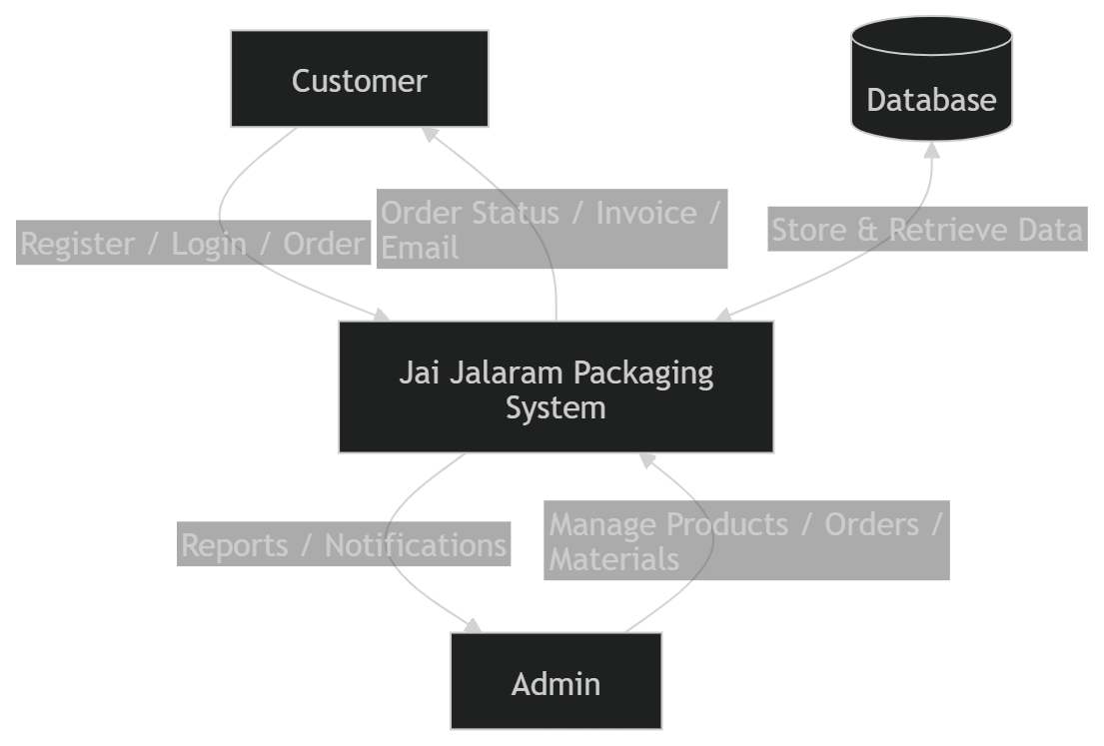
Level 1 :
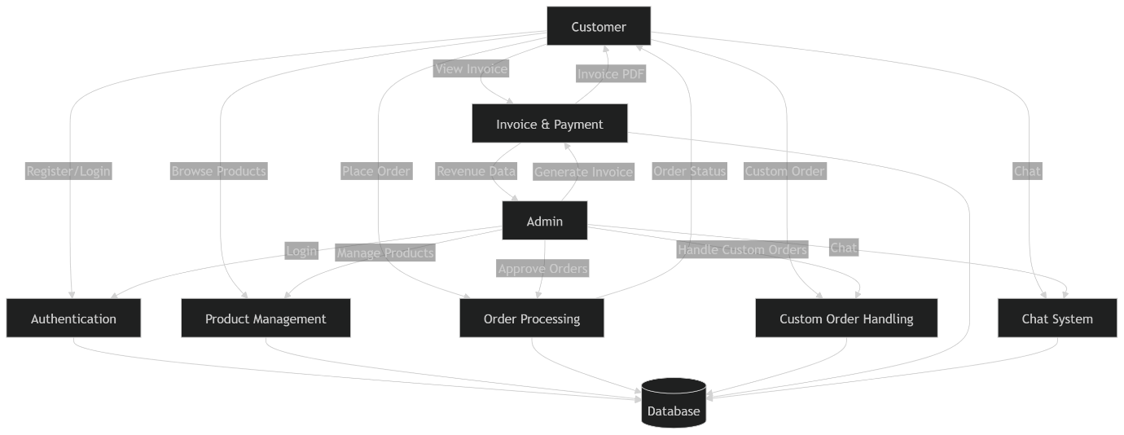
Use Case Diagram

Flowchart :
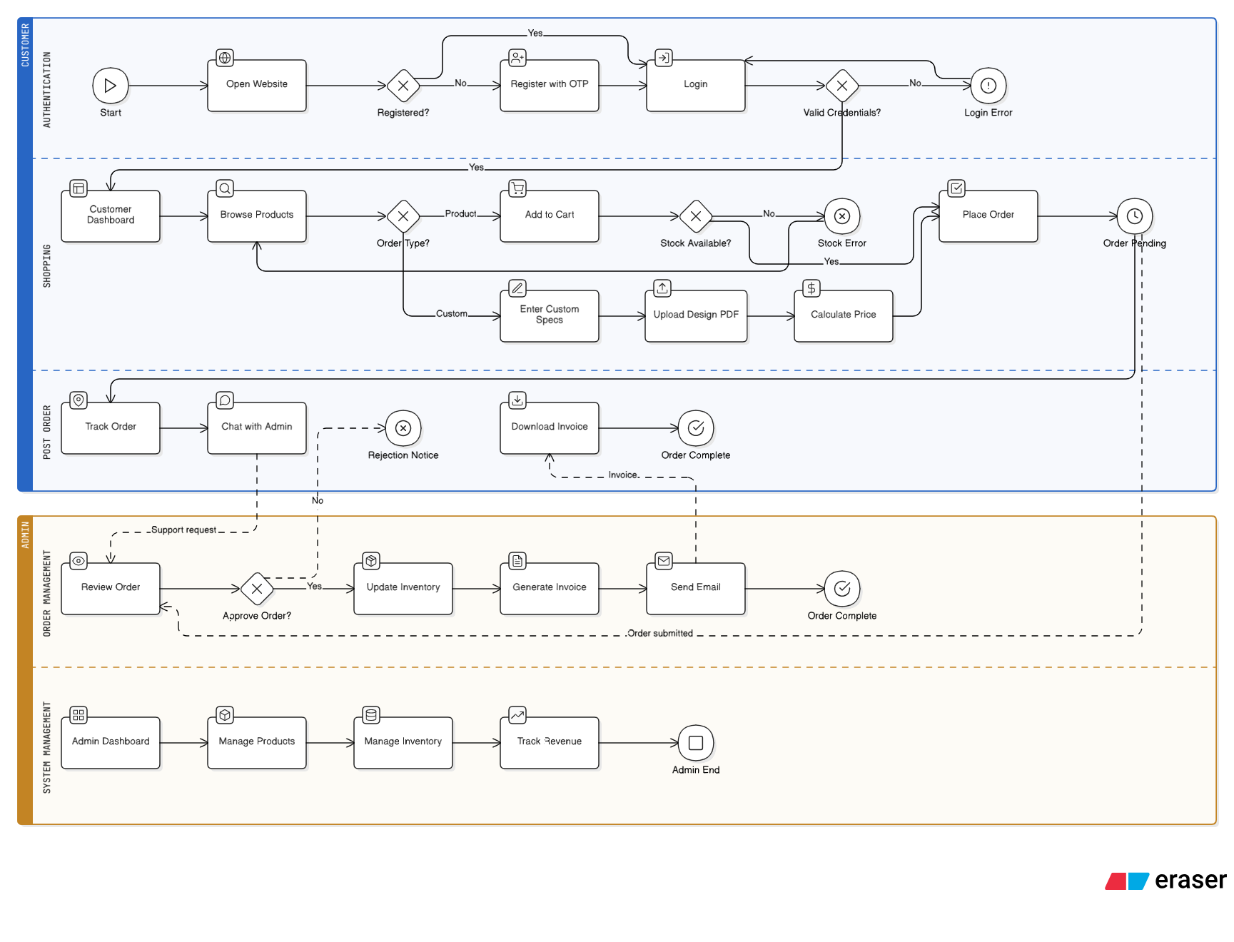

System Architecture Diagram:
